Decision Aids and Mentoring

Sarah Moss-Horwitz

# Introduction

Peer mentoring is defined as an informal relationship between two individuals based on the premise that mentors can give advice to mentees based on their own personal experiences. Mentorship is popular both informally through a social relationship, as well as in more formal contexts, such as part of a support system for new hires. Mentoring is particularly utilized in the University context, with built in mentoring structures such as Resident Assistants, Greek Life mentor systems, and career advising. Key to all of these peer mentoring programs is the assumption that **mentor are not experts**, but rather students that can offer their knowledge to those younger. Yet, the assumption that mentors, even those with the best of intents, are capable of giving meaningful advice is difficult to evaluate. Mentors are tasked with the difficult role of deals with a variety of different types of problems, and helping a peer navigate such complex, often emotional decisions can be tremendously difficult.

I am interested in how decision aids and tools can support peer mentors in providing advice and support. Decision aids have been used in supporting medical shared decision making for patients for over fifty years, yet lack of robust theoretical analysis has slowed the transfer of decision supports into more informal decision making areas. I am interested in exploring the use of decision aids in mentoring as a tool to support shared decision making between a mentor and peer mentee, and consider the relative advantages of past and existing decision aid models in this context. Throughout this process, I seek to address the issue of evaluation and outcomes, considering what it means for a decision aid to be “successful” in a context with minimal metrics of short term outcomes. I am interested in exploring the careful balance between increasing rationality in decision making, and supporting healthy satisficing.

# Purpose of Decision Aids

Based on the theory of Bounded Rationality, individuals are limited in their ability to rationally make decisions by the amount of information that they have, the cognitive limitations of their minds, and the finite amount of time they have to make a decision. Theoretically, decision aids increase the efficiency of finite cognition and time, which can either be considered a means to maximizing the amount of information that people can reasonably evaluate, or to simply support them in making a choice that satisfices their primary needs. The way in which decision aids accomplish this end is justified through three primary arguments; they can improve shared decision making by supporting communication between multiple stakeholders, reduce uncertainty in outcomes by providing increased information about options and outcomes, and breakdown complex decisions into smaller, more manageable decisions.

## Communication between Multiple Stakeholders

While we often think of our decisions as our own, the reality is that many decisions involve multiple “stakeholders” with different perspectives and opinions. For example, a patient deciding between medical procedures certainly relies on the insight of their doctor, and may also be considering the perspective of family and friends. A decision making tool could offer the ability to include the perspective of multiple stakeholders into the decision both by documenting the perspectives and mediating the process of collecting perspectives by allowing multiple stakeholders to add their perspectives.

## Reducing Uncertainty

Decision aids can reduce uncertainty by providing increased information about multiple options and their potential outcomes. Complex decisions, whether choosing between medical options or a major, often involve an overwhelming amount of information, and decision makers often struggle to navigate these options without falling to heuristics and biases. To the extent that the options are known, and their outcomes predictable, decision aids can present such information in a clear and unbiased way. While a person might also be capable of communicating this information, the use of a non-human media offers the distinct advantage of reducing either the bias of or reality of bias of the communicator to one of the options. It also has the advantage of increasing the perception of autonomy for the decision maker, as they are directly interacting with the information, rather than receiving through an expert.

## Breaking Down Complex Decisions

Decision aids can break down complex decisions into smaller decisions, reducing cognitive overload. Complex decisions, particularly those with long term outcomes, rarely involve a singular question, but rather a series of many micro decisions that have large impact. For example, in choosing a major there are many levels of decisions that can be broken down.

# Types of Decision Aids

Judgement and behavioral decision making offers a number of different techniques to improve decision making through decision aids. All of these decision aids are designed to address three main moments in the decision making process- eliciting values, generating choices and exploring their outcomes and deciding between choices based on outcomes and values. However, the ways in which decision aids address each of these steps are diverse. A very mainstream approach to decision supports is the six-stage shared decision making process in which decision makers are presented options, provided information on benefits and risks, encouraged to evaluate the options based on their goals and concerns, make a decision, and assisted to implement. This approach makes two main assumptions that limit its utility; decision makers have values and goals and that there are known benefits and risks involved in the choices. Additionally, there is ambiguity in this approach in which benefits

* 6 stage shared decision making process
* balance sheet
* pro/con list
* psychodrama

Type 1: Traditional Six-Stage Shared Decision Making Process

1. Invite the patient to participate
2. Present the options
3. Provide information on benefits and risks
4. Help the patient evaluate the options based on his or her goals and concerns
5. Facilitate deliberation and decision making
6. Assist with implementation

Janis and Mann (1976) analyzed how stress negatively affects decision making and considered why people often fail to look into available alternatively when consequences are at stake. They took two different strategies, the first quantitative and the second qualitative. For the quantitative approach, they developed a procedure, known as the Janis-Mann procedure, that uses a balance sheet approach to document utilitarian gains and losses, coupled with approval and disapproval, for the decision maker and others around them (Janis, 1976). For the qualitative approach, the patient instead participated in a scenario that required them to “project themselves into the future and improvise a vivid retrospective account of what happened as a consequence of choosing one or another alternative”. (Janis, 1976).

# Limits of Decision Aids

While decision aids have gained momentum, research into judgement and decision making reveals that there are some core assumptions that these aids rely on:

**Assumption 1: Explicit interventions are better than implicit strategies.**

Decision aids are designed to be “interventions” that encourage people to make more well-thought out decisions, but they fail to explicitly teach the implicit strategies for making a better decision.

**Assumption 2: Maximizing decision is a viable strategy.**

Moreover, the process of using a decision aid is often designed to maximize, rather than satisfice. This can lead to too much introspection and attention to detail, that may disrupt intuitive processing and interfere with people’s ability to focus on relevant information, resulting in less discriminating thinking and inferior decision making. (Nelson)

**Assumption 3: People have preexisting, well-formed preferences and values that merely need to be revealed through some elicitation process.**

In attempting to help people make their values more consistent with their choices, decision aids often take great pains to illicit values from decision makers both through revealed preference and expressed preference tasks. Many studies confirm that people are often inconsistent in their preferences across tasks, and there is a lack of confirmation of whether any of these strategies can reveal “true” values, or whether the elicitation tasks by default bias patients in some way.

# Shared Decision Making and Peer Mentoring

Mentoring, defined in this paper as “a relationship in which a more experienced or more knowledgeable person helps to guide a less experienced or less knowledgeable person”, is often seen as a way to support decision making. Mentoring can occur in explicit “mentorships”, as well as informal friendships. Moreover, being a mentor or being mentored can occur, if lucky, throughout a person’s life. For the purpose of this paper, I am going to focus on peer mentoring, both where there is a formal understanding that one peer is the “mentor” and the other is the “mentee”. This distinction is important, as many mentorships are informal and unnamed, which leads to a different dynamic in terms of how peers support each other.

As with medical decision making, mentors have experience and knowledge of options that can support the decision making of their mentees. However, unlike in medical decision making, mentors are not always aware of the information and options that will be relevant to share or have objective data of the benefits and risks. Additionally, while medical decisions are typically made consciously and explicitly, the daily decisions that college students make are often less overt. Therefore, there is a need for an additional step to identify key decisions as they are being made. Simply recognizing that one has the control to make decisions, rather than becoming “stuck” in situations can be empowering. Research led by Professor Linda Flower, CMU English, on mentoring and decision making suggests that shared decision making can increased “locus of control” for disadvantaged youth, and encourage increased responsibility taking.

A simple model of shared decision making for mentors involves the following steps:

1. Identify a decision that is considered difficult and important.
2. Elicit mentee values and goals.
3. Mentee and mentor generate multiple options for the decision.
4. Provide information on multiple options for the decision.
5. Help evaluate the options based on his or her values and goals.
6. Facilitate deliberation and decision making.
7. Assist with implementation.

# Peer Mentoring Decision Aid

How can decision aids support shared decision making in peer mentoring, a process that has ill-defined decisions, outcomes and options? To begin, decision aids can and should not be designed to serve as replacements for the value inherent in a mentor relationship. The real value in conversations between mentors and mentees is typically not the “content” at hand, but rather the anecdotal conversation that builds a connection at a social-emotional level. The overly structured use of decision aids within this relationship threatens to riff between the two humans, and block natural, spontaneous dialogue. Moreover, the nature of the types of ill-defined decisions that peer mentors discuss further limits the capability of the decision aid, as there is limited ability for a decision aid to perfectly match such complex, unpredictable decisions.

However, the structure of a decision aid can be designed to support mentors and mentees engaging in a collaborative, thoughtful conversation that can be difficult to approach alone. Similar to medical decision aids, this implies that the mentee has autonomy over the decision making process, but additionally it should support the mentor by providing opportunities throughout the process to engage collaboratively.

Based on previous research, I designed a decision support for mentors and mentees to use together to help one person (the mentee) evaluate and make a decision. Traditionally, mentoring is based in face to face conversation, however I chose to design a web app “decision aid” to be able to meet the needs of a growing number of virtual mentorship programs. While this may add a secondary layer of complexity, as interactions and rapport in a virtual environment are different from those in a physical environment, however research on other mentoring tools has shown that the quality of interactions via online chat can be as effective as face-to-face mentoring (Bagley). Therefore, given the context of the decision aid tool, part of the challenge is to envision how two users can remotely synchronously and asynchronously be involved in the process, and the means through which they should be able to collaborate and communication.

The primary way that the users communicate directly is through an online chat interface, however evers

The decision making intervention is designed with both quantitative and qualitative features. In the quantitative component, mentees will weigh decision choices based on their predicted outcomes. In the qualitative component, mentees and mentors will collaboratively role-play options and outcomes. In future evaluation of this design, it will be important to consider the relative effectiveness and potential interactions between these parallel approaches, and test both separately and together. To support the ideation of this concept, I created preliminary wireframes to illustrate the interactions within the system and between mentors and mentees.

1. Identify Decision

As previously mentioned, identifying a singular decision moment is a key pain point for mentors seeking to help mentees improve decision making. While eliciting high level values can be difficult, eliciting more tangible goals is more reliable and easier for decision makers to engage with. Based on goals that the mentee expresses, the mentor, and decision support aid, can probe the mentee to identify barriers and difficult decisions related to their stated goals.

1. Generate and Evaluate Choices:
   1. Mentee and mentor generate multiple options for the decision.
   2. Generate information on multiple options for the decision.
   3. Evaluate the options through role-play.
   4. 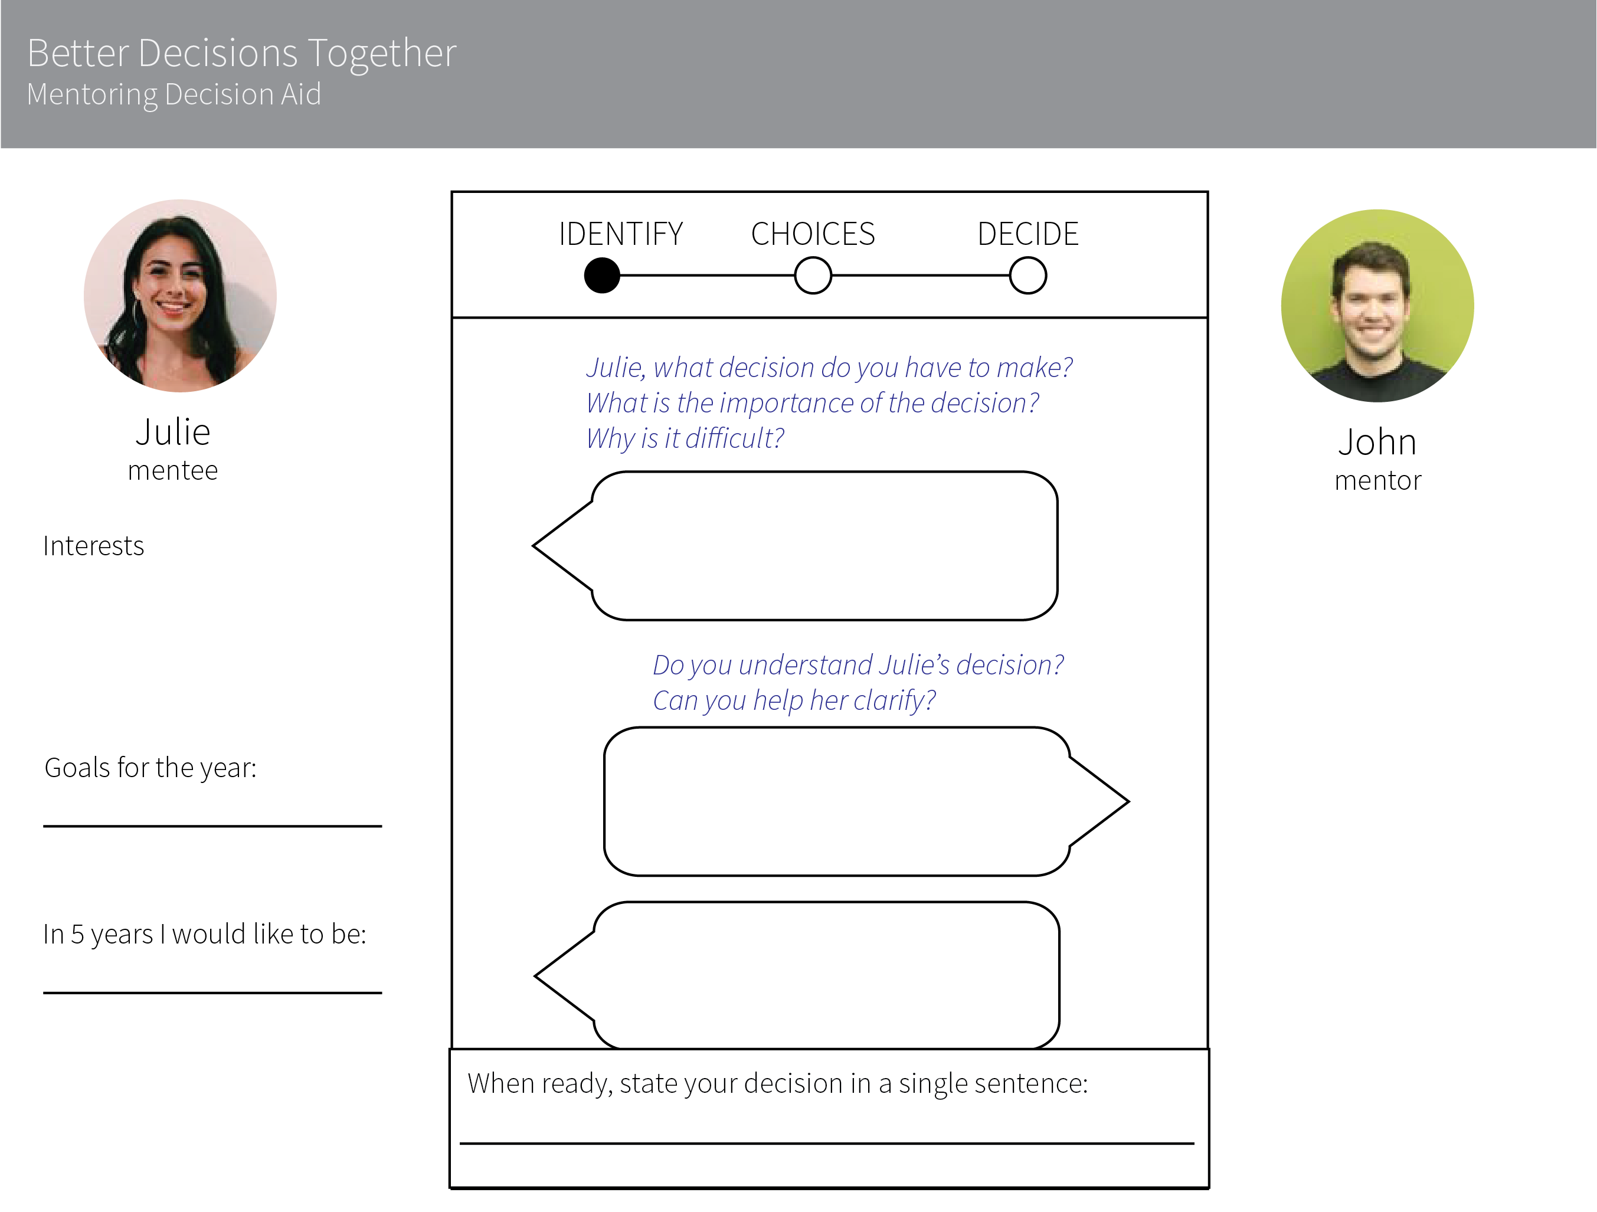Evaluate the options quantitatively based on his or her values and goals.

Figure 2: Identify a Decision

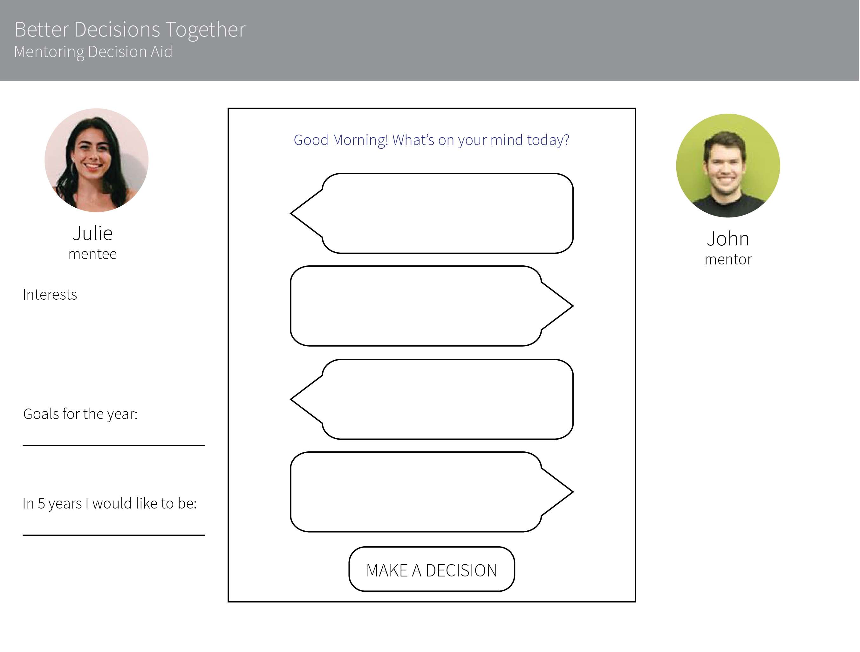

Figure 1: Chat Interface

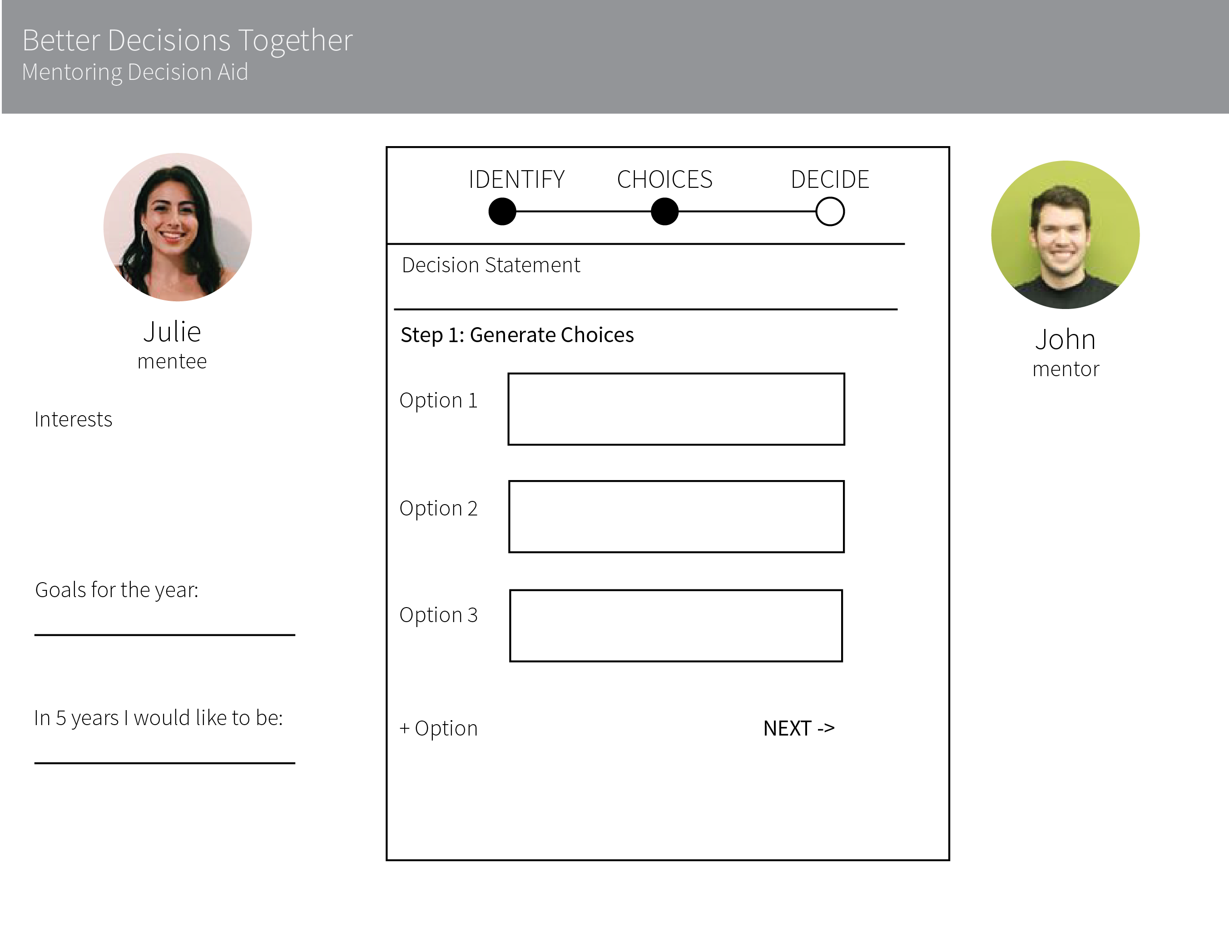

ase Studies of Usability Issues in Decision Aid Implementation

InformedTogether: Usability Evaluation of a Web-Based Decision Aid to Facilitate Shared Advance Care Planning for Severe Chronic Obstructive Pulmonary Disease https://humanfactors.jmir.org/2015/1/e2/

The Influence of Decision Aids on High School Students’ Satisfaction With Their College Choice Decision http://psp.sagepub.com/content/25/10/1293.full.pdf+html

Creating Effective Decision Aids for Complex Tasks

http://uxpajournal.org/creating-effective-decision-aids-for-complex-tasks/

http://fhs.mcmaster.ca/main/news/news_2015/share_it_decision_aids.html

Interactive Decision Aids

http://link.springer.com/chapter/10.1007%2F978-3-7908-2769-9_5

The Future of Decision Aids in Social Contexts: Novel Technology and Interactives

http://jamanetwork.com/journals/jamainternalmedicine/fullarticle/1570089

* Virtual Reality
* Verbal interactions
* Computer vs. Human interface
* Personalization
* Social decision aids
* Learning algorithms and feedback

# Conclusions

# Bibliography

Bagley, E.A. and D.W. Shaffer. "Stop Talking And Type: Comparing Virtual And Face-To-Face Mentoring In An Epistemic Game". *Journal of Computer Assisted Learning* 31.6 (2014): 606-622. Web. 14 Dec. 2016.

Fischhoff, B. (2008). Assessing adolescent decision-making competence. *Developmental Review* 28(1), 12–28.

Hastie, R., & Dawes, R. M. (2001). Rational choice in an uncertain world: The psychology of judgment and decision making. Thousand Oaks, CA: Sage Publications.

Janis Irving L. and Mann Leon (1976). Decision Making: A Psychological Analysis of Conflict, Choice, and Commitment. New York: Free Press, 1977. Pp. xx + 488.

Keren, G., & Teigen, K. H. (2004). Yet another look at the heuristics and biases approach. *Blackwell handbook of judgment and decision making*. Malden, MA: Blackwell Publishing.

Kmett, C. M., H. R. Arkes, and S. K. Jones. "The Influence Of Decision Aids On High School Students' Satisfaction With Their College Choice Decision". *Personality and Social Psychology Bulletin* 25.10 (1999): 1293-1301. Web. 14 Dec. 2016.

Nelson, W. L., P. K. J. Han, A. Fagerlin, M. Stefanek, and P. A. Ubel. "Rethinking the Objectives of Decision Aids: A Call for Conceptual Clarity." *Medical Decision Making* 27.5 (2007): 609-18. Web.

Shim, J.P. et al. "Past, Present, And Future Of Decision Support Technology". *Decision Support Systems* 33.2 (2002): 111-126. Web. 14 Dec. 2016.

Simon, Herbert A. "Rationality, Bounded." *The New Palgrave Dictionary of Economics* (n.d.): 893-95. Web.

Uhler LM, Pérez Figueroa RE, Dickson M, McCullagh L, Kushniruk A, Monkman H, Witteman HO, Hajizadeh N. InformedTogether: Usability Evaluation of a Web-Based Decision Aid to Facilitate Shared Advance Care Planning for Severe Chronic Obstructive Pulmonary Disease. JMIR Hum Factors 2015;2(1):e2